GCA Usage Instructions
- Access the link below (both PC and Mobile can access):
https://mcpc-gca-maygodblessyou.streamlit.app/

- Click the button as shown in the diagram below:
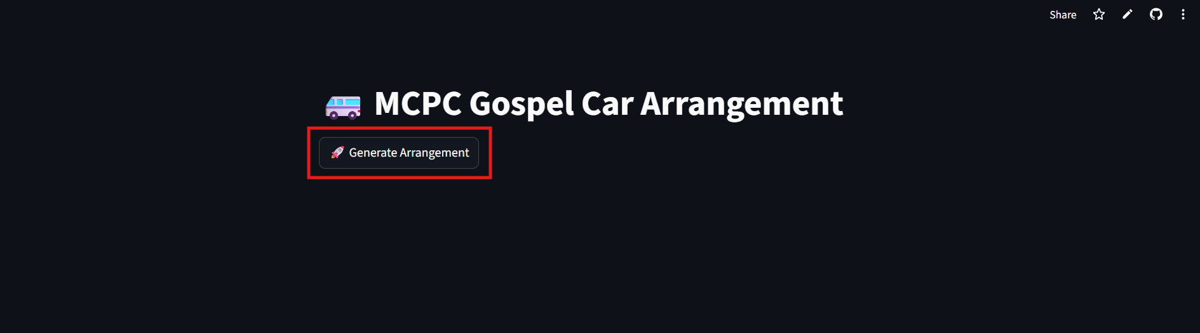

- The arrangement message will be generated when the button is clicked
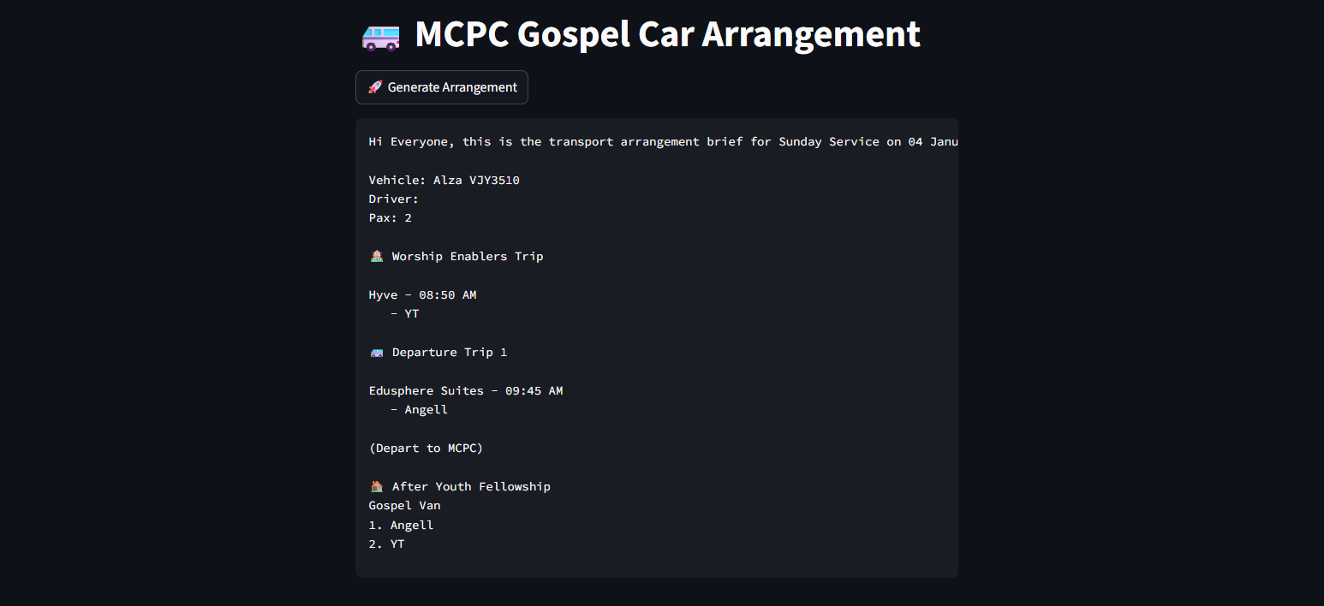

- Click the button at top-right corner of the arrangement message to copy it
